DEPARTMENT OF EDUCATION
Townsend Building 401 Federal Street Suite 2
Dover, Delaware 19901-3639
DOE WEBSITE: http://www.doe.k12.de.us
C22-69

Susan S. Bunting, Ed.D.
Secretary of Education Voice: (302) 735-4000

Dear Early Learning Provider,
Tiered reimbursement is intended to support programs in their quality of care, providing quality professional development, and the recruitment and retention of well-qualified staff. In order to effectively evaluate the tiered reimbursement program, the Office of Early Learning will be monitoring program usage to determine if technical assistance is needed. Programs will be required to submit documentation showing how the funds were utilized. A template is provided. Reports may be confirmed via audit at any time. Recipients are expected to maintain supporting documentation for expenses for a period of no less than two years.
The reimbursement rate is determined by the program type, county, children’s age, and attendance of POC eligible children. Payments are linked to the attendance that is entered by the 15th of the month by the program into the POC portal. Payments will be electronically deposited monthly into the program’s account that is associated with the Division of Social Services. This is a separate payment from the POC payment. Failure to submit the attendance by or on the 15th will result in a program not receiving a tiered reimbursement payment.
If a program is under an enforcement action by the Office of Child Care Licensing, they will be ineligible for their tiered reimbursement payment. A program may also be ineligible if they had significant changes occurring in their program administration or operation or if they have been administratively or financially sanctioned by any government office or agency. Programs that have IRS liens or court issued judgements will be subject to having their tiered reimbursement payment automatically redirected to the IRS or court judgement.
Below is the anticipated payment schedule for tiered reimbursement. Payments are expected to be deposited by the end of the month, but may be delayed due to holidays or unexpected circumstances. Please note that the payment schedule is subject to change. The April and May attendance is currently planned to be paid in July due to fiscal year close out processes.

Failure to submit the Tiered Reimbursement Annual Agreement and the Annual Reporting form on or before July 1, 2021 will result in suspension of tiered reimbursement payments.

2021 – 2022
Stars Tiered Reimbursement Dates
Attendance Month | Payment Date
April - 2021 | End of July, 2021
May - 2021
June - 2021 | End of August, 2021
July - 2021 | End of September, 2021
August - 2021 | End of October, 2021
September - 2021 | End of November, 2021
October - 2021 | End of December, 2021
November - 2021 | End of January, 2022
December - 2021 | End of February, 2022
January - 2022 | End of March, 2022
February - 2022 | End of April, 2022
March - 2022 | End of May, 2022

For the Department of Education:
5/19/2021
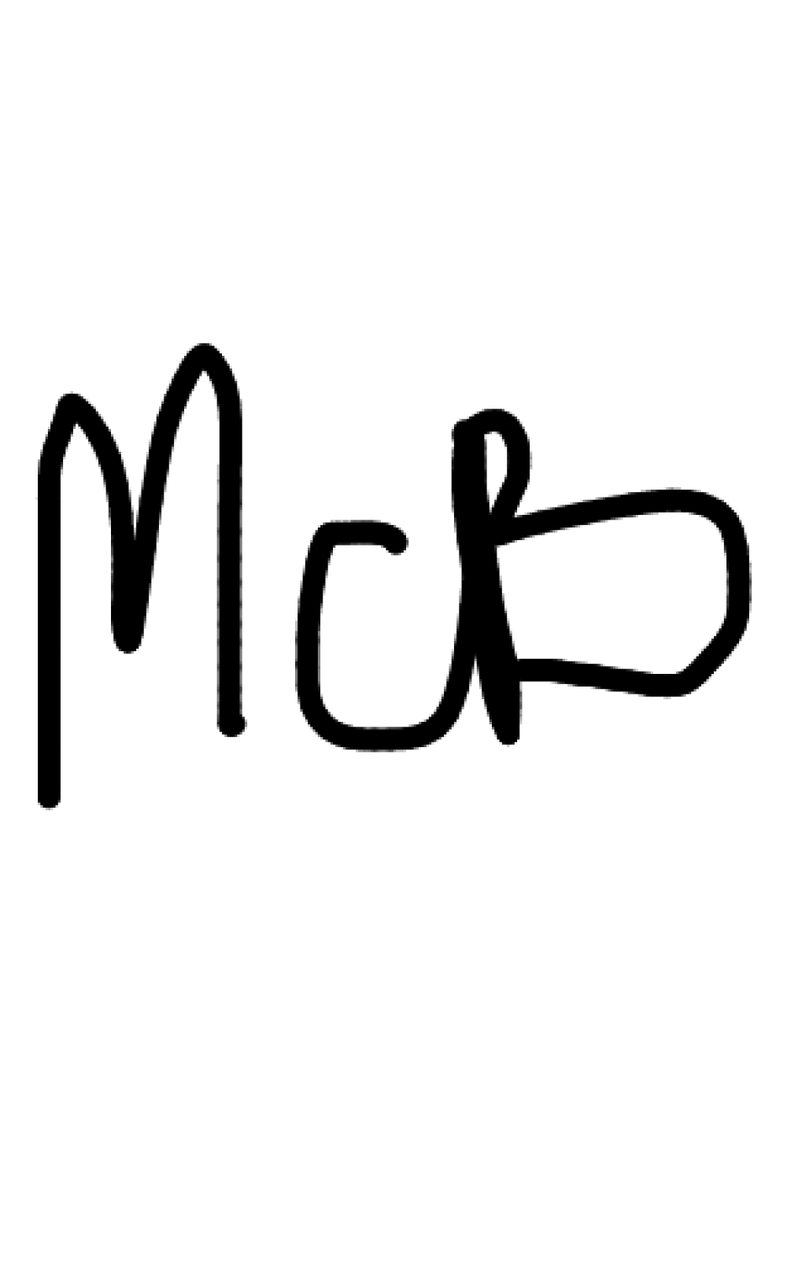
Kim D. Klein, Associate Secretary Date

THE DELAWARE DEPARTMENT OF EDUCATION IS AN EQUAL OPPORTUNITY EMPLOYER. IT DOES NOT DISCRIMINATE ON THE BASIS OF RACE, COLOR, RELIGION, NATIONAL ORIGIN, SEX, SEXUAL ORIENTATION, GENDER IDENTITY, MARITAL STATUS, DISABILITY, AGE, GENETIC INFORMATION, OR VETERAN’S STATUS IN EMPLOYMENT, OR ITS PROGRAMS AND ACTIVITIES.

Tiered Reimbursement Agreement

As a recipient of tiered reimbursement issued by the Delaware Department of Education for Delaware Stars level 3, 4, or 5 quality rated programs, for the attendance period of April 2021 to March 2022, I/We agree to the following:
As the program administrator/owner I/we understand that I/we must abide by all tiered reimbursement policies and procedures set by the Delaware Department of Education.
As the program administrator/owner I/we understand that the tiered reimbursement funds are to be utilized to achieve and sustain a quality program and to be actively working towards the next star level or maintaining a Star level 5.
As the program administrator/owner I/we understand that the program must submit a report showing that the tiered reimbursement funds were utilized for providing quality assured professional development training/activities for staff, the recruitment and retention of well qualified staff, quality of care, and materials purchased.
As the program administrator/owner I/we understand that attendance must be reported no later than the 15th of the month for the previous month to the Division of Social Services; no further adjustment can be made to the attendance after this date. Failure to submit attendance by the 15th of the month will result in forfeiture of the Stars Tiered Reimbursement for that attendance month.
As the program administrator/owner I/we understand that the Delaware Tiered Reimbursement Agreement of Understanding must be completed in its entirety for each yearly attendance period and returned to the Delaware Department of Education in order for the program to receive the tiered reimbursement funds.
As the program administrator/owner I/we understand that the Delaware Department of Education staff or an authorized agent of the Delaware Department of Education may conduct a random audit of the utilization of the tiered reimbursement funds given the program at any time.
Program Information (please complete all information)
Program Name: |  | (check one)  Family or Center
Business License  or Non-Profit #: | Purchase of  Care ID#: | Child Care  Licensing#:
Program Address:
Mailing Address:
Program Phone #: | Program Email:
Contact Person: | Title:
As the program administrator/owner the above program information has been completed with true and current information. As the program administrator/owner, I/we acknowledge that I/we have read and understand this agreement. The signature below indicates acceptance of all terms and conditions of this Delaware Stars Tiered Reimbursement Agreement of Understanding.

Program Administrator/Owner (please print) |  | Program Administrator/Owner Signature Date

Please keep a copy of both pages for your records.

2

